# 

Congratulations on completing this Tableau module, now let’s apply what you have learned. If you need more review, take some time and go back through the lessons and practice. Use this worksheet to log your responses to the questions below. Then submit this worksheet to Canvas using the instructions in your online classroom.

1. Using the Superstore dataset, create a bar chart showing the Total Profit by Sub-Category.1

[insert screenshot here]

1. Which sub-categories had profits above the average? (Hint: Add a reference line at the average to see how each sub-category is performing against the average).

[type response here]

1. Why would you want to add a reference line at the average of your view?

[type response here]

1. What are the three most common trend types?

[type response here]

1. Based on the chart to the right:
   1. What is that kind of line called?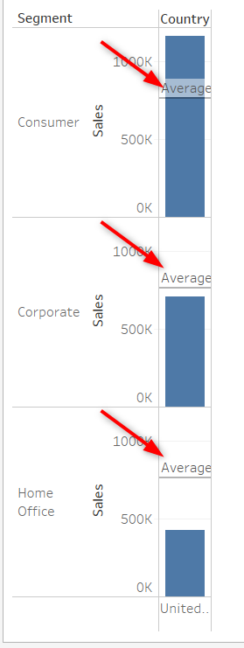

[type response here]

* 1. Is this for the entire table, pane, or cell?

[type response here]

* 1. What conclusions can you draw based on the line and the aggregate?

[type response here]